Outputs:

1.Output of square number pattern:

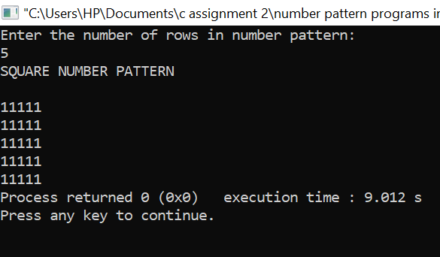

2.Output of number pattern 1:

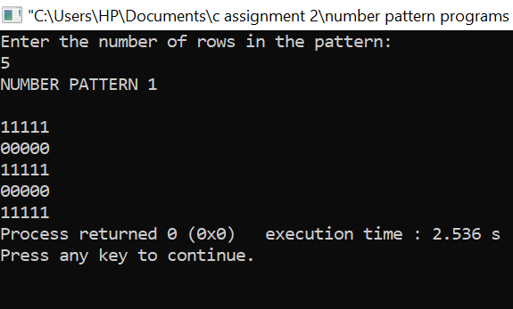

3.Output of number pattern 2:

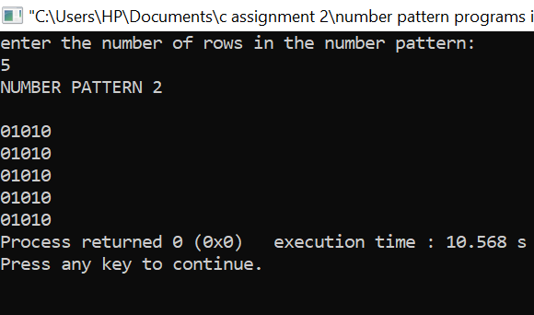

4.Output of number pattern 3:

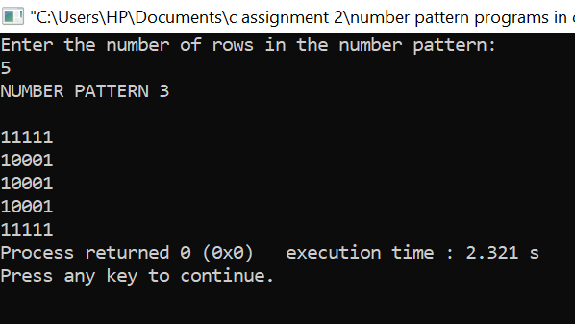

5.Output of number pattern 4:

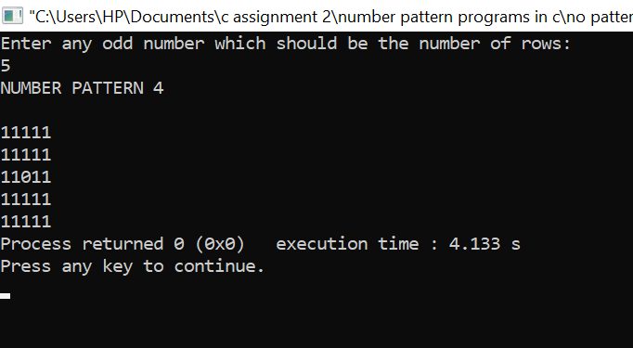

6.Output of number pattern 5:

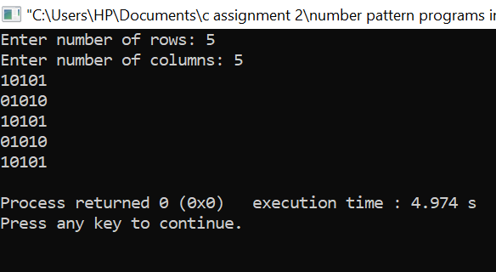

Thank you!!!